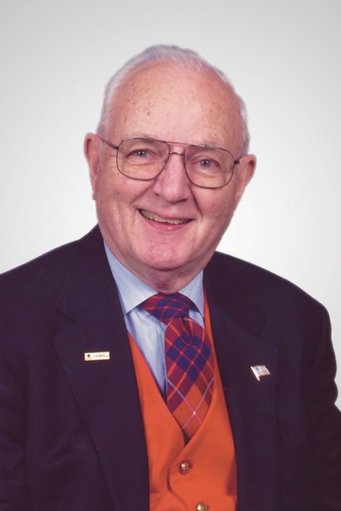
On May 12, 2021, Frank Crumback Fryburg was released from his recent suffering and pain and passed peacefully to his final reward. Throughout his 94 years he was a loving father, grandfather and great grandfather; a loyal friend, fraternity brother, Mason, church supporter, politician and servant of the communities where he lived throughout his life.

Frank was born on July 28, 1926 in Abington, PA. He graduated from Abington Senior High School, earned a Bachelor of Science in Physics from Penn State University and a Masters in Business Administration from the Wharton School at the University of Pennsylvania.

One of his core characteristics was loyalty: 37 years working for RCA, almost 75 years as an active member and leader of the Sigma Pi Fraternity, a life-long fan of the Penn State Nittany Lions, 20 years in the Naval Reserves, and a dedicated and hardworking member of the Republican Party.

Frank leaves a large family legacy of which he was very proud; survived by his daughters Susan Scott (Jeff), Joyce Rothenberg (Mace), Barb Harvey and his sons Howard Fryburg (Pat), Karl Fryburg (Barb), Fred Bicksler, 13 grandchildren and 20 great grandchildren. He is preceded in death by his first wife Jane Fryburg and second wife Maggie Fryburg and son William Bicksler.

A memorial service will be held on Saturday, June 5th at the St Thomas Episcopal Church (301 St Thomas Road, Lancaster, PA). There will be a meet and greet with the family from 11 to 12, and a memorial service at noon followed by a reception in the church fellowship hall.

In lieu of flowers, please send donations to the St. Thomas Episcopal Church.

